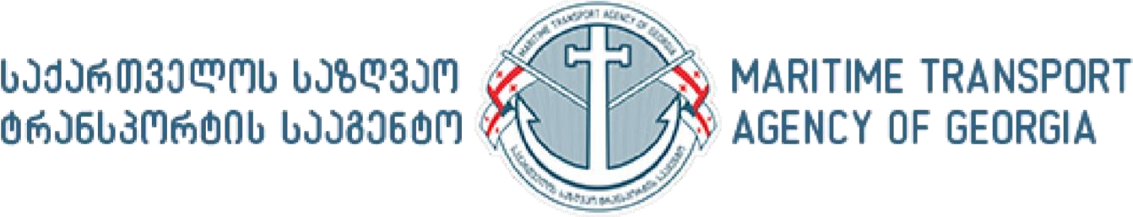

Ministry of Economy and Sustainable Development of Georgia
Maritime Transport Agency Director’s Order N15
3 December 2021 წ.
Batumi, Georgia

On amending Order 05 of April 06, 2020 “On certain measures to be taken in the Georgian seafarers’ certification and training system in connection of the spread of the novel coronavirus COVID-19”

According to Article 20 and paragraph 4 of Article 25 of the Organic Law of Georgia “On Normative Acts” and sub-paragraph “d” of paragraph 2 of article 4 of Order №1-1/585 Of the Minister of Economy and Sustainable Development of Georgia “On Approval of the Charter of the Legal Entity of Public Law the Maritime Transport Agency”, I order the following:

Article 1. Order 05 of April 06, 2020 “On certain measures to be taken in the Georgian seafarers’ certification and training system in connection of the spread of the novel coronavirus COVID19” shall be amended and the following sub-paragraphs „3^{9“} and „3¹⁰“ shall be added:
„3⁹. Certificates of Seafarers, who are now engaged in international navigation and whose certificates (certificates of competency or proficiency, seamen’s books) are expiring before 1st March 2022, upon the written application of the shipowner or/and ship manager company, shall be extended for a period not exceeding 3 (three) months starting from the moment of expiry.
3¹⁰. Subject to the same conditions of laid down in sub-paragraph 3⁹, medical certificates of Seafarers, who are now engaged in international navigation and whose certificates are expiring by 1st March 2022, shall automatically be renewed for a period of three months.

Article 2
This order shall come into force from the moment of its publication.

Director Tamar Ioseliani

